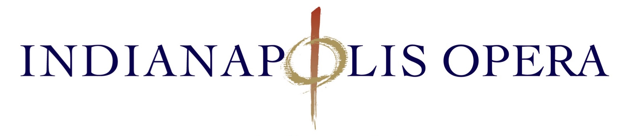
10th ANNUAL “LOBSTERPALOOZA” 2019

SPONSORSHIP OPPORTUNITIES

An experience like no other, “LobsterPalooza” is an evening of unadulterated FUN, fabulous FOOD, DANCING under the stars with 300 of Indy’s best revelers! Scheduled for Saturday, July 20st, the 10th annual summer evening event is held on the grounds of the Basile Opera Center at N Pennsylvania and 40th Street. With a few acres of lawn and a nice, big parking lot, there’s plenty of room for tables, a great DJ, several open bars and yes, boiling pots of lobsters, corn on the cob, mussels and clams! We’d love to engage you in the action with a tasty sponsorship opportunity!

PRESENTING SPONSOR $10,000
UNSOLD
People will be swept away with YOUR business and brand as THE title sponsor of “LobsterPalooza”! Surely one of the most anticipated summer events in Indy and absolutely one of the most fun! Jump on this opportunity and ride it away!

Benefits include:

- The opportunity to showcase your products on site before and during the event.
- Your logo as Presenting Sponsor on all printed materials, related to the event: Save the Date Cards, invitations (1,500 piece mailing), posters, and all event promotional materials.
- Your logo as Presenting Sponsor on all virtual: IO’s website, twitter, Facebook, Instagram.
- Your logo as Presenting Sponsor on all event signage.
- Recognition and thanks at all public relations venues: radio, TV, and service group presentations.
- Recognition and thanks from General Director’s stage comments at the event and VIP Experience.
- 16 complimentary tickets (@ $250) to the VIP Experience at 6pm, including 2 reserved tables for 8 at LobsterPalooza Dinner
- 10% sponsor discount on extra seating.
All use of sponsor’s logo will be sent to sponsor for approval prior to printing or posting on IO’s website.

VIP EXPERIENCE SPONSOR – Sold___________ $7,500

Who wouldn’t want to touch shoulders – elbows?! And schmooze with approximately 150 VIP patrons and party-goers? This is a very popular part of “LobsterPalooza”, scheduled before the event takes place, resplendent with all kinds of adult beverages and delicious hors d’oeuvres – put your business name on it and let it shine!

Benefits include:

- Your logo as the VIP Experience sponsor on printed materials, related to the event: Save the Date cards, invitations (1,500 piece mailing), posters, signage and other promotional material.
- Your logo as VIP Experience Sponsor on Table Cards at VIP Experience area.

VIP EXPERIENCE SPONSOR Benefits continued…

- Your logo as VIP Experience Sponsor on all virtual platforms: IO’s website, twitter, Facebook, Instagram. (
- Your logo and delineation as VIP Experience Sponsor on IO’s website with hyperlink to your business’ website.
- Recognition and thanks from IO’s General Director at the VIP Experience and event itself.
- 8 complimentary tickets (@ $250) to the VIP Experience Reception at 6pm, including a reserved table for 8 at LobsterPalooza Dinner Event
- 10% sponsor discount on extra seating.
All use of sponsor’s logo is available to be sent to sponsor for approval prior to printing or posting on IO’s website.

RAFFLE SPONSOR $5,000_____
UNSOLD

SEAFOOD SPONSOR -Sold___________________ $5,000___

As friends, kick up their heels and celebrate summer under the stars … BUT… their most important reason for attending “LobsterPalooza” is the lure of succulent, butter-bathed lobsters, steamy clams and mellow mussels! Serve it all up under your company’s banner!

Benefits include:

- Your logo as Seafood Sponsor on printed materials, related to the event: invitations (1,500 piece mailing), posters, and event signage.
- Your logo as Seafood Sponsor at the event.
- Your name on all virtual platforms: IO’s website, twitter, Facebook, Instagram.
- Recognition and thanks from General Director from stage.
- 8 VIP complimentary tickets (@ $250) to the VIP Experience Reception at 6pm, including a reserved table for 8 at LobsterPalooza Dinner
- 10% sponsor discount on extra seating.
- Complimentary valet parking.
All use of sponsor’s logo is available to be sent to sponsor for approval prior to printing or posting on IO’s website

MUSIC AND ENTERTAINMENT SPONSOR - Sold__ $2,500

Just as Calypso enchanted Odysseus with singing, your business will surely captivate “LobsterPalooza’s” guests by providing highly danceable music from the swaying deck aka the stage.

Benefits include:

- Your logo as Music and Entertainment Sponsor at the event.
- Your logo as Music and Entertainment Sponsor on all virtual platforms: IO’s website, twitter, Facebook, Instagram.
- 4 complimentary VIP tickets (@ $250) to the VIP Experience Reception at 6pm, including reserved seats for 4 at LobsterPalooza Dinner
- Recognition and thanks from General Director at event.
- 10% sponsor discount on additional seats.

WINE PULL SPONSOR - Sold $2,500____

DECORATIONS SPONSOR Sold $2,500_

Spread the good cheer all night long as your company is featured alongside the evening’s special drinks and Lobster Maine décor.

Benefits include:

- Your logo as Sponsor at the event.
- Your logo as Sponsor on all virtual platforms: IO’s website, twitter, Facebook, Instagram.
- As the wine pull sponsor you will have your name on the wine bags.
- 4 VIP complimentary tickets (@ $250) to the VIP Experience Reception at 6pm, including reserved seats for 4 at LobsterPalooza Dinner
- Recognition and thanks from General Director at event.
- 10% sponsor discount on additional seats.
All use of sponsor’s logo is available to be sent to sponsor for approval prior to printing or posting on IO’s website

VALET SPONSOR $1,200
UNSOLD

It is how we arrive, and when that special valet service greets you so will the splendor of the evening kick off in all the right ways.

Benefits include:

- Your logo as Sponsor at the event.
- Your logo as Sponsor on all virtual platforms: IO’s website, twitter, Facebook, Instagram.
- Your logo as Sponsor logo and name on IO’s website with hyperlink to your business’ website.
- 2 VIP complimentary tickets (@ $250) to the VIP Experience Reception at 6pm, including reserved seats for 2 afterwards at LobsterPalooza.
- 10% sponsor discount on additional seats.
All use of sponsor’s logo is available to be sent to sponsor for approval prior to printing or posting on IO’s website

* All sponsorship levels will receive a post-event report. An IO representative will schedule a time to meet with you after the event and present a sponsorship fulfillment report and evaluation of the return on your investment.
